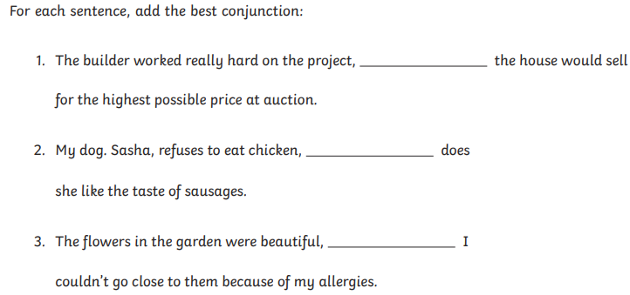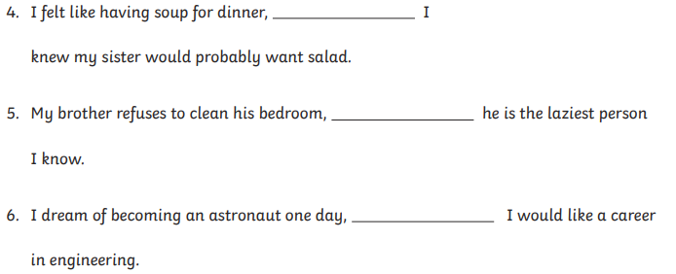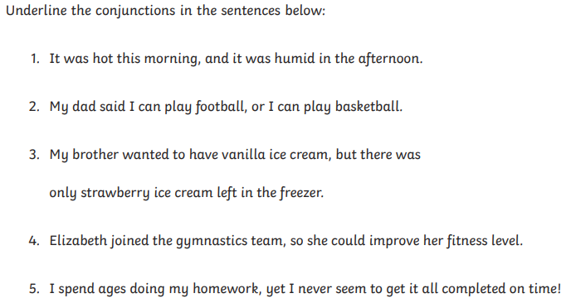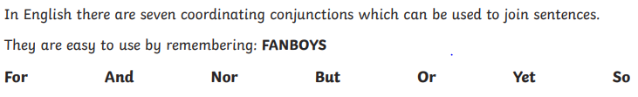Autumn 1 2025 Week 6 SPAG homework Gold Class

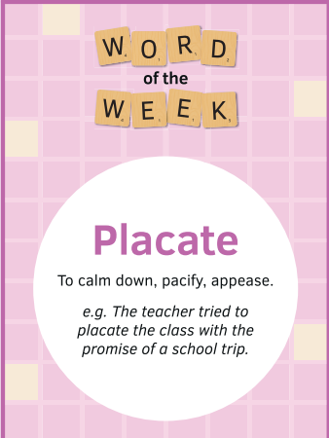

Find 5 synonyms and 5 antonyms for the word of the week :

______________________________________________________________________________________________________________________________________________________________________________________________________________________________________________________________________________________________________________________________________________________________________________________________________