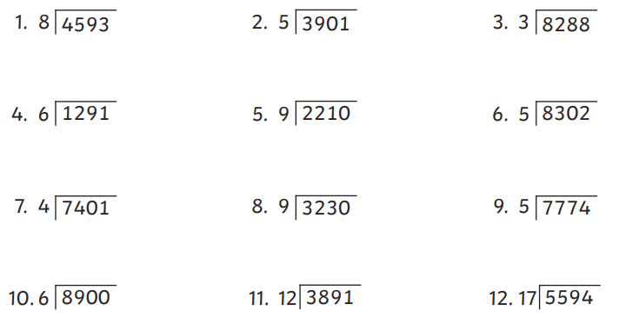

Autumn 1 week 5 Year 6

