Autumn 1 2025 Week 5 SPAG homework Gold Class

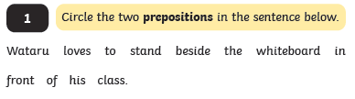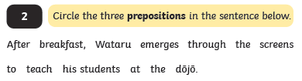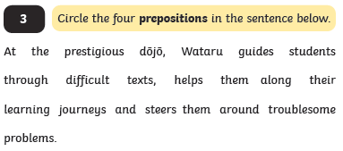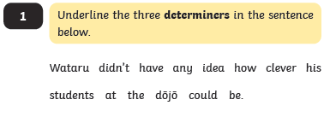

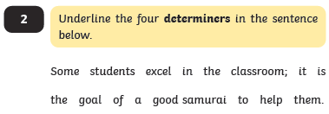

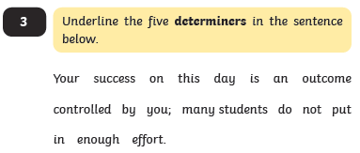

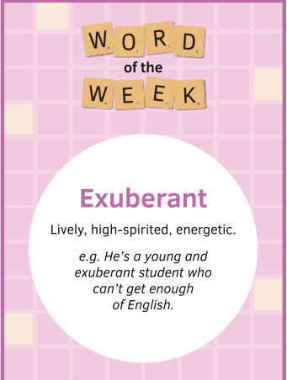

Find 5 synonyms and 5 antonyms for the word of the week :

______________________________________________________________________________________________________________________________________________________________________________________________________________________________________________________________________________________________________________________________________________________________________________________________________