Autumn 1 2025 Week 1 SPAG homework Gold Class

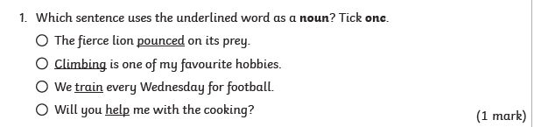

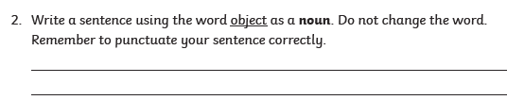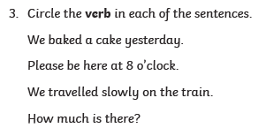

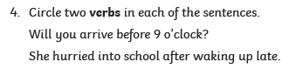

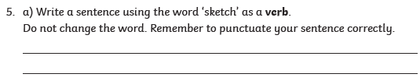



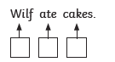

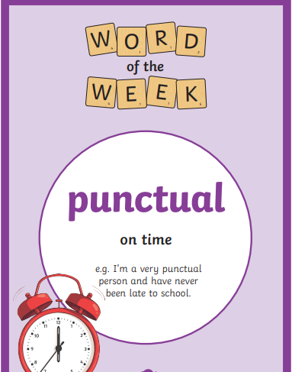

Find 5 synonyms and 5 antonyms for the word of the week :

______________________________________________________________________________________________________________________________________________________________________________________________________________________________________________________________________________________________________________________________________________________________________________________________________