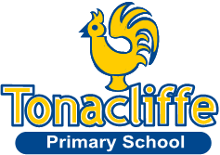

Tonacliffe Primary School Art and Design Year A 2024 - 2025
 | Autumn 1 | Autumn 2 |  | Spring 1 | Spring 2 | Summer 1 |  | Summer 2
KS1 | Drawing - Explore and draw  Rosie James, Alice Fox |  |  | Sculpting - Stick Transformation  Chris Kenny |  | Painting - Expressive painting  Marela Zacarías, Charlie French, Vincent Van Gogh, Cezanne
LKS2 | Drawing - Gestural Drawing with charcoal  Heather Hansen, Laura McKendry, Edgar Degas |  |  | Painting - Cloth, thread, paint  Alice Kettle, Hannah Rae |  | Sculpting - Clay  Rachel Dormor, Emily Ward
UKS2 | Sculpting - Clay  (6 hours)  Chris Gryder, Louise Goodman |  | Drawing - 2D to 3D drawing  Lubaina Himid, Claire Harrup |  |  |  | Painting - Exploring Identity  Njideka Akunyili Crosby, Yinka Shonibare, Thandiwe Muriu, Mike Barrett

